COLÁISTE CHILLIAIN
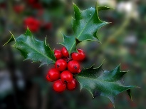NUACHTLITIR NA NOLLAG 2020
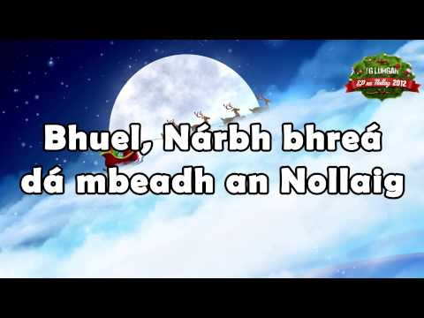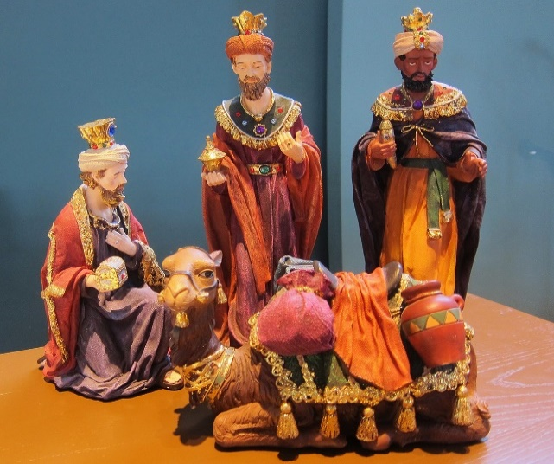

Focal ón bPríomhoide
Ag aimsir na Nollag bímid dírithe ar cheiliúradh agus craic, le clann agus cairde. Is fíor dúinn é sin arís i mbliana ach faraoir tá a lán daoine in easnamh an Nollaig seo, idir dhaoine a cailleadh agus iad siúd nach bhfuil in ann taisteal nó cuairt a thabhairt. Guím Nollaig shuaimhneach, síochanta oraibh uilig agus le cúnamh Dé tiocfaimid tríd an paindéim seo de réir a chéile i 2021.
Ba mhaith liom mo bhuíochas a ghabháil leis na daltaí ar dtús báire – thuig sibh tábhacht na rialacha nua agus thacaigh sibh leo. Táim fíor-bhuíoch don tacaíocht agus tuiscint ó na tuismitheoirí freisin, go háirithe ag tús na scoilbhliana nuair a bhuail an Covid an scoil go dona. Ach thar aon ghrúpa eile molaim na múinteoirí, atá tar éis éacht a dhéanamh ó thosaigh an paindéim seo – ag obair faoi choinníollacha oibre difriúla ó aon bhliain eile. Táim fíor-bhuíoch agus faoi chomaoin mhór agaibh.

At Christmas time we focus on celebrating and fun, with family and friends. This is also true this year but unfortunately there will be many missing – those who have passed and those who cannot travel or visit. I wish you all a pleasant, peaceful Christmas and I pray that we will come through this eventually during 2021.
I would first of all like to thank and praise the pupil, who have understood and supported the new rules this year. I also very much appreciate the support and understanding of our parents, especially during the difficult covid related start we had to the school year. However, may I reserve a particular word of praise and thanks to the teachers and staff of Coláiste Chilliain, who have worked under very different conditions compared to any other year. I am very grateful.
Nollaig Shona agus athbhliain faoi mhaise.
Feargal Ó Giolláin
Torthaí Scrúduithe na Nollag
Tá na torthaí Nollag ar fáil anois ar VS Ware – ma tá fadhb ag aon duine rochtain a fháil ar VS Ware seol r-phost chugainn ag: eolas@colaistechilliain.ie agus cuirfear ar an mbóthar ceart sibh.
The Christmas Exam results are now available on VS Ware. If you have difficulty accessing VS Ware please send us an email to: eolas@colaistechilliain.ie and we will explain how to logon etc.
Idirbhliain –
Tá tionscnamh idir láimhe ag an Idirbhliain –ag cruthú Seomra Ranga Lasmuigh. Taispeánann na pictiuiri na bínsí atá á ndéanamh don seomra agus an cruth a bheidh ar an seomra. Táimid an-bhuíoch don obair dheacair atá ar siúl ag na daltaí agus na múinteoirí atá á stiúradh.
The TY are creating an Outdoor Classroom as a project, supervised by a landscape gardner and teachers from the school, for whom we are very grateful. The photos below show the wooden benches made in the woodwork class that will be part of the room and the area and design being used is to be seen in the second photo.
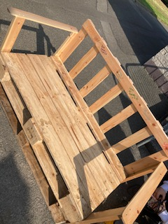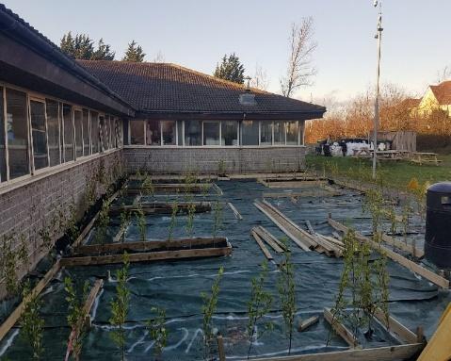
Ar deireadh d’éirí leis an Idirbhliain dul ar thuras i mbliana agus roghnaíodh an Zú toisc go raibh said sa nuacht le déanaí agus iad i gcruachás airgid. Is léir thíos gur bhaineadar taitneamh as an lá agus go raibh an aimsir cineálta leo.
At long last the TYs managed to go on a school trip this year. We chose the zoo as it has been in the news lately regarding funding issues. The pupils seemed to enjoy the day and as the photos suggest the weather was kind to them.

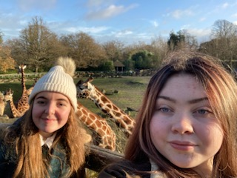 | 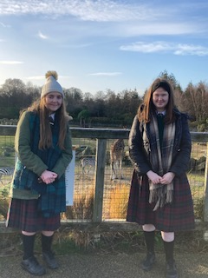

Tá an Rang Idirbhliain Fiontair gnóthach ó thús na bliana ag baint triail as gnóanna éagsula a bhunú – idir scannáin, tráth na gceist &rl. Cuid eile den Fiontair ná Aonach Nollag – chun scaradh sóisialta a chinntiú rinneadar an aonach thar cúpla Dé hAoine agus don chuid is mó bhí gach earra díolta roimh chríoch na scoile.
The TY Enterprise class has been busy since the start of the year setting up little businesses/fund raising event like film periods, quizzes etc. The Christmas market is also integral to the Enterprise class and this year, to maintain social distancing the market was held over several Fridays. Almost all their products were sold out before the day finished – maith sibh.
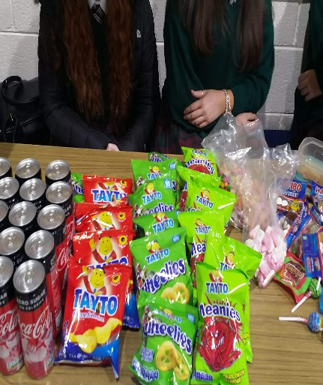 | 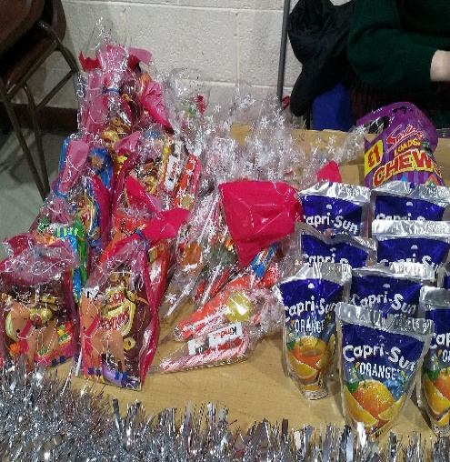 | 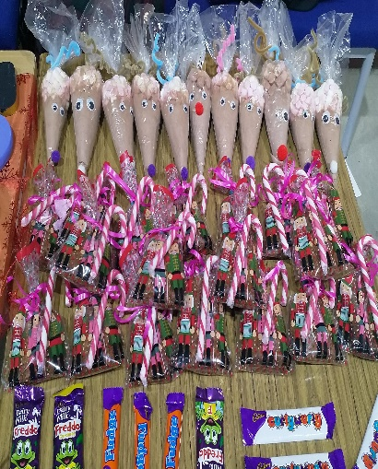

Thosaigh an Idirbhliain le Ceardlann Foiréinseach eagraithe ag Ollscoil Teicneolaíochta BÁC (TUD). Chomh maith le sin bhí Lá Eolaíochta Fíorúil acu – cuireadh an lón thíos ar fáil dóibh i rith an Lá ar líne!
The TY began with a Forensics Workshop, organised by TUD (Technological University Dublin). That was followed a few weeks later by a virtual science day organised as part of Science Week. Lunch (below) was provided on the day.
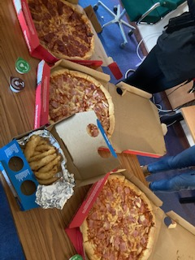

Scothscoláirí / Pupils of the Year (2019/20)

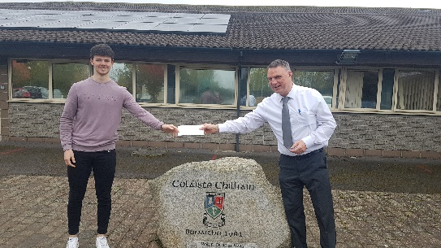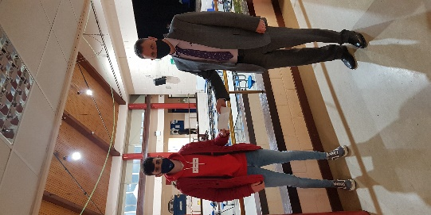
Bronnadh scoláireachtaí ar luach €500, urraithe ag Cairde Chilliain ar na daltaí thuas, Ben Inglis agus Seosamh Ó Muirí. Níor éirí linn iad a bhronnadh ar Sheosamh go dtí an Aoine seo caite. Tá Ben I UCD ag déanamh staidéar ar Airgeadais agus tá Seosamh i TUD ag déanamh staidéar ar Mhargaíocht. Comhgáirdeachas don bheirt acu agus go n-éirí go geal leo sa todhchaí.
Cairde Chilliain’s 2 scholarships to the value of €500 each was presented to Ben Inglis and Seosamh Ó Muirí. Due to lockdowns etc Seosamh only received his award on Friday last. Ben is in UCD studying Finance (the highest points course in the country) and Seosamh is studying Marketing in TUD. Congrats and our best wishes for the future.

Lá na nGeansaithe Nollag & Bailiúcháin Bia
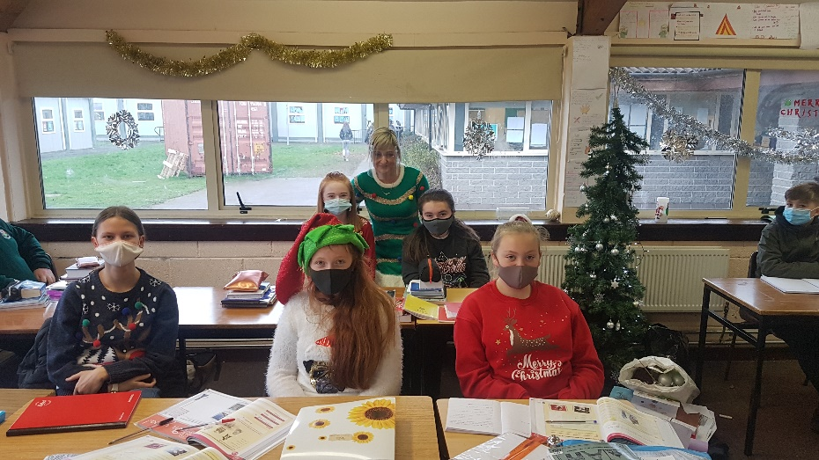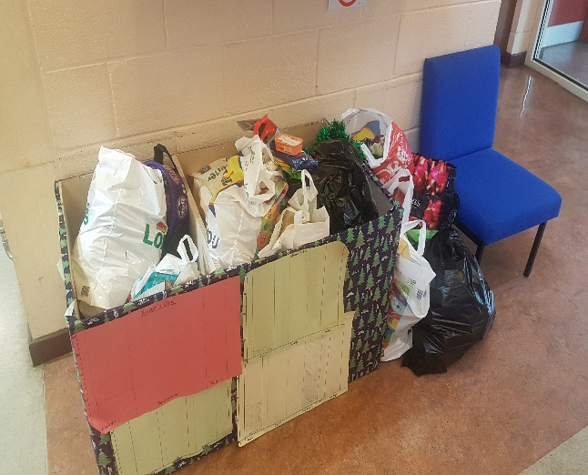
1 Beithe agus an múinteoir Alsún lena ngeansaithe galánta! Boscaí Bia Lán!
D‘eagraigh Comhairle na nDaltaí lá geansaithe Nollag agus bhailigh an Idirbhliain an t-airgead le dul chuig Simon. Chomh maith le sin bhí an Comhairle gnóthach ag eagrú an bailiúchan bia do Dheoise Bh.ÁC – feictear gur bailíodh an t-uafás bia i mbliana agus molaimid na daltaí dá bharr – míle buíochas. Bhuaigh 2bliain 2 Cnó Capaill an comórtas don meid is mó a a bailíodh.
The Student Council organised a Christmas Jumper Day in aid of Simon and the council were also busy collecting food for the Dublin Diocese appeal. As you can see the boxes were overflowing this year and we salute the generosity of you and the pupils. “Cnó Capaill won the competition for the most food items collected.

Cairde – iPads nua.
Focal tapaidh lenár mbuíochas a chur in iúl arís do Chairde Chilliain (Comhairle na dTuismitheoirí) don tacaíocht d’oideachas na ndaltaí. Tá bosca eile iPadanna ceannaithe acu don scoil agus iad á gcur i mbun úsáide faoi lathair.
Just a quick note of thanks to Cairde Chilliain (parents’ council) once again for their support of education in the school. They paid for yet another box of iPads which are coming on stream at the moment.
Gluais
Is grúpa cinnirí ón 5ú bhliain iad ‘Gluais’ a dhéanann traenáil san idirbhliain le tabhairt faoi róil éagsúla cinnireachta sa scoil. Sa ghriangraf thíos feictear na daltaí atá anois tar éis a mbliain mar chinnirí sa scoil a chomhlíonadh agus atá anois ag fágáil an dualgas sin ar dhaltaí nua-thraenáilte sa chuigiú bhliain. Gabhaimid buíochas dóibh agus don ghrúpa nua agus tugaimid buiochas freisin do Mhaebh Ní Chléirigh as ucht an feachtas seo a eagrú.
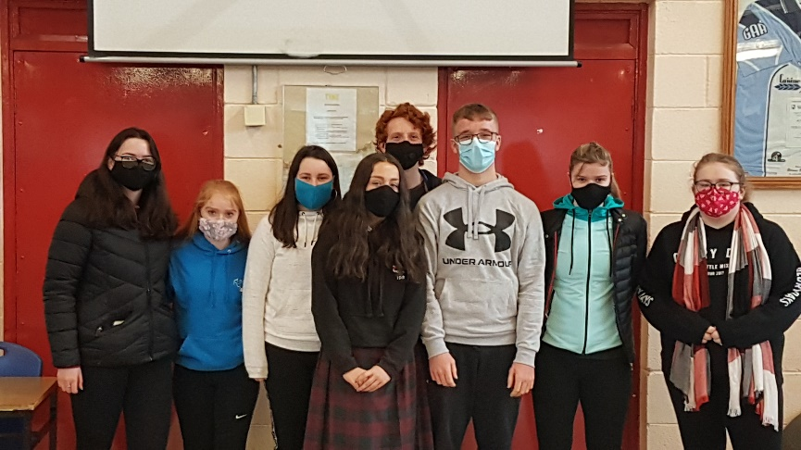
Gluais is a Leadership Initiative in the school where 5th years, trained during TY, take on various leadership roles in the school. The 6th year group below is finishing its term of office and they are handing over to the recently trained 5th year group. We are very impressed with and grateful for their input and contribution. Maebh Ni Chléirigh organised this initiative agus gabhaimid buíochas léi.
Cip Iúir – Kippure – Turas Tíreolaíochta Bhliain 6 – Geography Trip.
In aineoinn na srianta ar thaisteal d’éirigh le Bliain 6 dul ar thuras tíreolaíochta le linn mí Dheireadh Fómhair go Cip Iúir, Co. Chill Mhantáin. Is cuid tábhachtach den chúrsa Ardteite é an turas seo agus cé go raibh sé fuar ní raibh sé ag cur báistí agus d’éirigh leis na daltaí an tionscnamh a chríochnú. Buíochas le Sorcha agus Cathal a bhí á dtionlacan.
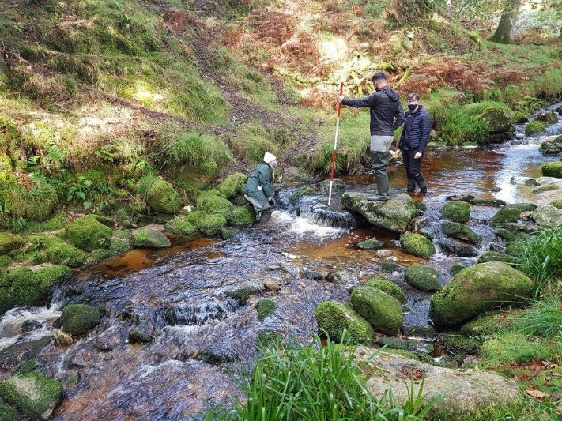

Despite the limitations imposed due to Covid the sixth years managed to go on their Geography trip to Kippure, Co. Wicklow. The trip is an important element of the Leaving Cert course and despite the cold the rain stayed off and they completed the assigned project. Thanks to Sorcha and Cathal for accompanying them.
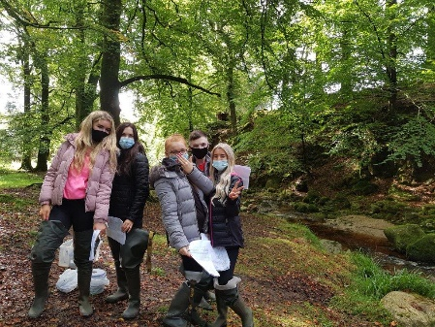 |  | 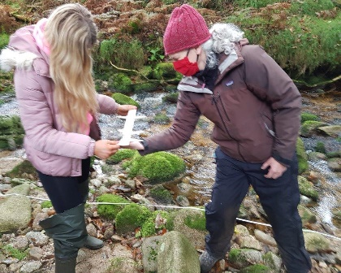

Comórtas Maisiúchain na Seomraí /Christmas Decoration Competition
D’eagraigh Comhairle na nDaltaí comórtasa maisiúcháin Seomraí i mí na Nollag agus rinne na daltaí an-iarracht spiorad na Nollag a mhúscailt ina seomraí ranga – ag crochadh maisiúcháin, ag déanamh ealaíne &rl. Rinne an Príomhoide agus an Leas-Príomhoide scrúdú ar na seomraí agus roghnaiodh na buaiteoirí seo a leanas;
The Student Council organised a Room Decoration competition for Christmas and a great effort was put into bringing the Christmas spirit into their base rooms. The principal and Deputy Principal judged the rooms and ranked them in the following order;

1ú Áit 6 Fuinseoige – S.3 2ú Áit 5 Seiceamar - Léachtlann
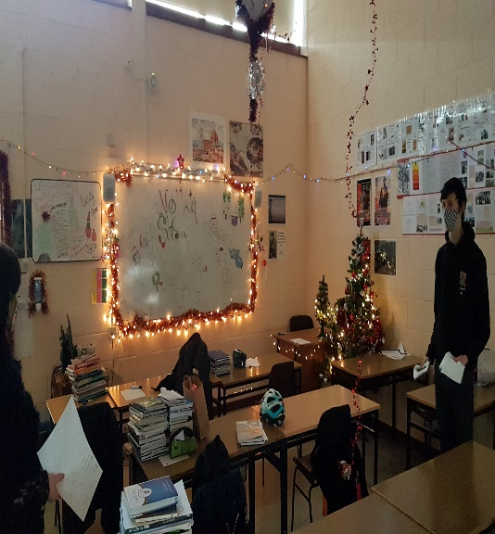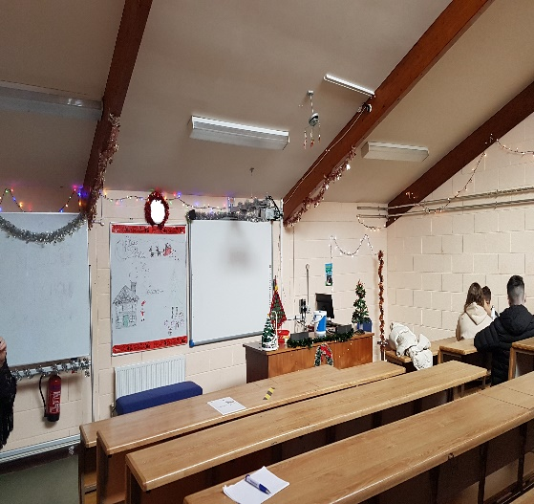
3ú Áit – 2 Cnó Capaill - Leabharlann 3ú Áit - 5 Seiceamair – Léachtlann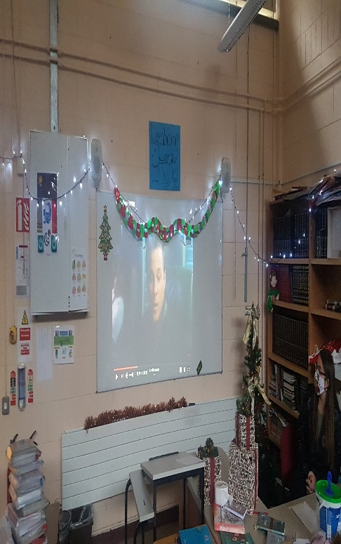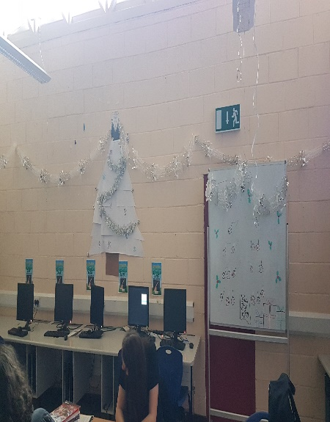
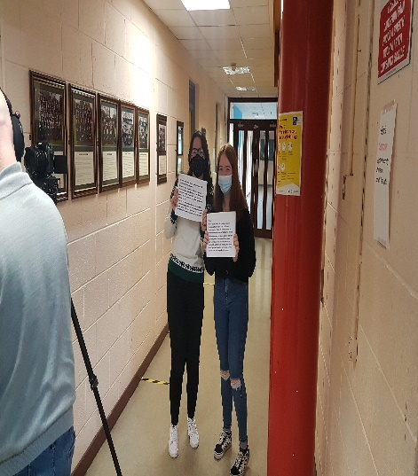 |  | 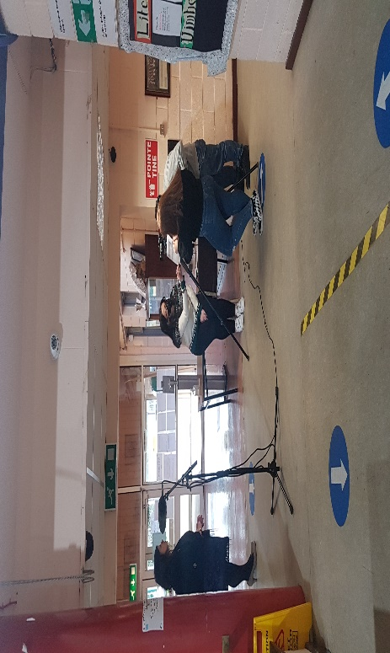
Bhí ‘Bluebird Productions’ sa scoil an tseachtain seo caite le físeán a chur le chéile mar ionadaí ar an Oíche Oscailte – sa ghriangraf fiectear beirt dhalta seú bliana ag cabhrú leis an leas-priomhoide ag taifead don bhfíseán.

‘Bluebird Productions’ were in the school last week creating a video to replace our usual Open Night. In the photo we see two 6th year students helping the Deputy Principal record a segment.

Míle Gaol / Goal Mile
Rinne 1 Giúise an míle do GOAL an Aoine seo caite mar chuid d’fheachtas an charthanacht airgead a bhailiú. Bhí rang corpoideachais ag an múinteoir Páidí Swinburne leo agus chomhlíon said na méadar cuí. | 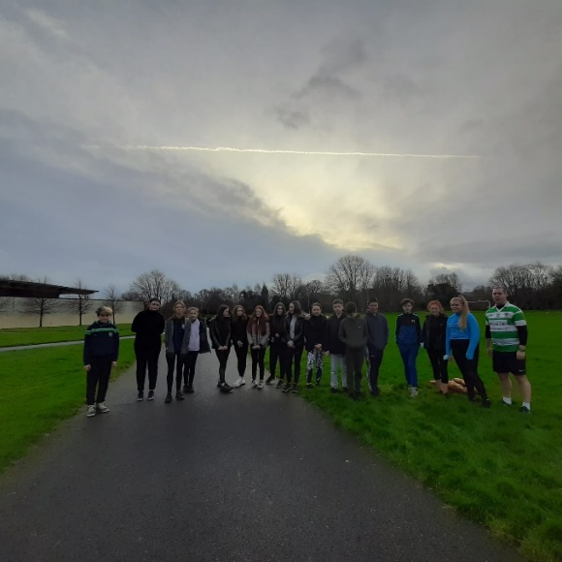 | 1 Giúise completed the GOAL mile last Friday in their support of the charity to raise funds. They completed the required distance in their PE class with Páidí Swinburne.

Lá Uachtar Reoite!!! Ice Cream Day!!!

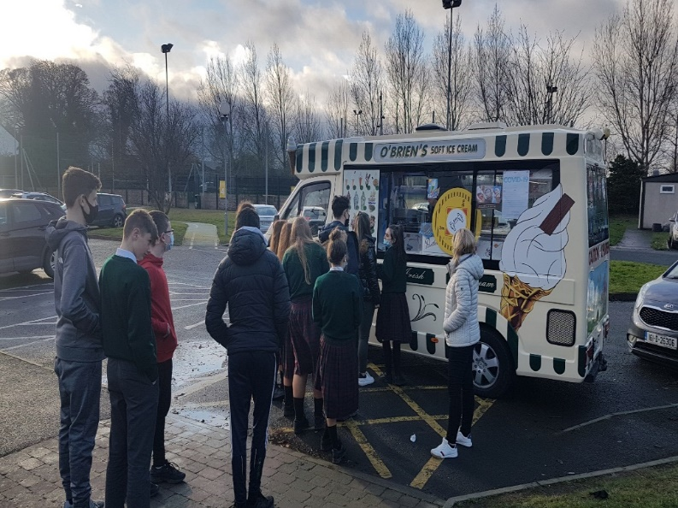

Míle buíochas do Chairde Chilliain arís as ucht tacaíocht a thabhairt don scoil an Chéadaoin, an 14ú Nollaig. Eagraíodh go dtiocfadh veain isteach agus go bhfaigheadh gach dalta uachtar reoite (99!!) mar chomhartha measa agus buíochais don bhliain chrua a bhí acu agus don chomhoibriu ó thángamar ar ais i mi Lúnasa.

We would like to thank Cairde Chilliain again for their support on Wednesday, December 14. An ice cream van was arranged to visit the school and every pupil was bought a 99! It was our way of acknowledging the tough year they have had and to thank them for their cooperation since our return in August.

